Blockchain for Information Assurance: A Systematic Review of Security, Privacy, and Trust
Faizan Ali , Muhammad Abdullah Khan , Muhammad Bin Waseem , Mujeeb U Rehman
Department of Cyber Security
Faculty of Computer and Engineering, Ghulam Ishaq Khan Institute of Engineering Sciences and Technology
Topi,Pakistan

Abstract—Blockchain technology provides transformative potential for information assurance through distributed ledgers, cryptographic security, and consensus mechanisms. This systematic review examines 24 peer-reviewed papers (2016-2024) analyzing how blockchain addresses security, privacy, and trust in information systems. We consider the blockchain models of Bitcoin and Hyperledger Fabric, their consensus schemes, smart contract security, privacy and governance models. Although the blockchain has strong integrity and non-repudiation, full confidentiality could only be realized with extra privacy measures. We provide blockchain mechanisms to IA goals taxonomy, threat models, privacy-preserving methods analysis and offer feasible advice on blockchain implementation in information assurance systems.
Index Terms—Blockchain, information assurance, security, privacy, trust, and consensus mechanism, smart contracts, zero-knowledge proofs, distributed ledger technology, cryptography, governance, compliance.

I. Introduction
Information assurance (IA) guarantees five fundamental security principles of information systems: confidentiality (keeping sensitive data private), integrity (preventing unauthorized modifications), availability (ensuring access when needed), authenticity (verifying source and legitimacy), and non-repudiation (preventing denial of actions). Traditional centralized systems, while widely deployed, face fundamental flaws including single points of failure (entire systems compromised if central server breached), vulnerability to insider threats (administrators with excessive privileges), and difficulties establishing trust across organizational boundaries where no single entity is universally trusted.
An entirely different concept is provided by blockchain technology, a cryptographically linked distributed ledger first introduced by Satoshi Nakamoto in 2008 with Bitcoin and which is kept in common by several parties and does not need a central authority. This decentralized architecture will overcome numerous old IA problems through the removal of central points of failure, the availability of audit trails that are transparent and tamper evident, and the application of cryptographic methods to guarantee integrity and authenticity of data.
Companies in all kinds of industries, such as finance (cross-border payments, securities trading), health care (medical records management), supply chain provenance tracking), government services (land registries, voting systems), and digital identity (self-sovereign identity) are turning to blockchain as a means of assuring information. The popularity of technology can be attributed to a few important properties: single points of failures are eliminated through decentralization, cryptographic connection of blocks makes it computationally costly to change historical data; transparency and, at the same time, pseudonymous features allow auditing and, possibly, protecting the privacy of everyone.
Nevertheless, blockchain cannot be considered a panacea. Practical applications are extremely problematic. Although they allow automated execution of business logic, smart contracts may have critical bugs that cost a significant amount of money, such as the 2016 DAO attack in which a reentrancy vulnerability was used to steal $60 million.
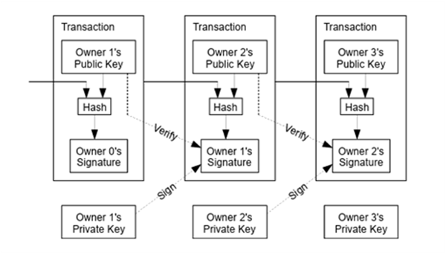
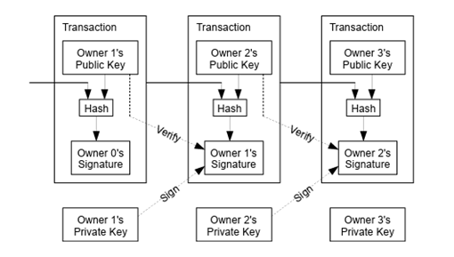
Privacy is a significant issue with the conventional blockchain deployments that make all transactions visible to all participants, creating tensions with confidentiality requirements and regulations like GDPR. Performance limitations are stark—Bitcoin processes approximately 7 transactions per second, Ethereum around 15-30 transactions per second, far below traditional payment networks like Visa which can make thousands of transactions per second at peak times. Also, the integrity that makes blockchain appealing to immutability is also causing issues when the data requires correction or when the rights to be forgotten rules must be fulfilled.
Our systematic review of the literature searched IEEE Xplore, ACM Digital Library, Springer, Elsevier ScienceDirect and arXiv to identify peer-reviewed articles published in 2016-2024. Out of a preliminary set of more than 150 papers, we chose 24 high-quality articles in the basic works (Bitcoin, Ethereum, Hyperledger Fabric), in-depth security analyses, privacy innovation (Zerocash, mixing networks), performance analysis, as well as application to domain. We are making contributions in the form of: (1) a detailed taxonomy of mapping the technical elements of blockchain to IA goals; (2) multi-layered threat model with real-life examples and mitigation strategies; (3) critical assessment of privacy-preservation methods with trade-offs analysis; (4) practical design patterns of IA applications; (5) recognition of open challenges and research opportunities
II.Background and Core Concepts

A. Blockchain Fundamentals
Basic Architecture: A blockchain is a distributed database which keeps an ever-expanding list of data known as blocks. Each block consists of a set of transactions, a timestamp, a cryptographic hash of the prior block, and a hash of that block, forming a chain, such that alteration of any block in history would involve recalculating of all the later blocks, which have been made computationally infeasible in well-designed systems. In 2008, Nakamoto, as indicated by Bitcoin, demonstrated how a decentralized network could maintain a single journal without making use of a central authority through novel use of consensus systems.
Consensus Mechanisms: A blockchain system can use many different consensus mechanisms, and each of them has its security, performance, and energy properties.
Proof of Work (PoW): Bitcoin also uses PoW which was initially used by Ethereum where the participants (miners) have to solve computationally intensive puzzles in an attempt to propose new blocks. The challenge makes the rewriting of blockchain history very expensive. Nevertheless, PoW uses a lot of energy (Bitcoin uses more energy than small nations) and reduces the number of transactions. Bonneau et al. present detailed discussion of PoW security features and attack combinations.
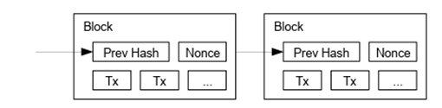
Proof of Stake (PoS): PoS allows proposers of blocks to be chosen not by the amount of computational work they perform but by the amount of stake they hold (i.e. investment in cryptocurrency), which drastically lowers the amount of energy used, and security is ensured through economic incentives, since attackers would have to buy large stakes, which is economically unprofitable. The evolutional change to PoS in Ethereum is one of the significant ones. Gazi and others examine PoS security assurance and long distance attack countermeasures such as the checkpointing.
Byzantine Fault Tolerance (BFT): BFT-based consensus, such as Tendermint (Kwon and Buchman) and Hyperledger Fabric (Androulaki et al.), can provide finality and can support arbitrary failure of nodes, including malicious behavior if few more than a third of nodes are faulty. BFT systems are generally faster in finality and have greater throughput than PoW or PoS but need to know, comparatively fixed list of authorizers, which makes them more permissible to a permissioned setting.
Smart Contracts:In 2014, Buterin proposed and in 2016, Wood described the Yellow Paper, which expanded the field of blockchain beyond simple value transfers to programmable transactions using smart contracts, or programs, which can run on the blockchain and execute themselves when specific conditions are satisfied. The smart contracts allow the issuance of complex business logic to be decentralized, such as financially using tokens to supply chain tracking. Nevertheless, smart contracts are posing serious security problems as thoroughly discussed by Atzei et al and Luu et al. Errors in contract code may cause significant financial loss - the 2016 DAO attack used a reentrancy vulnerability to drain about 60 million dollars. The vulnerabilities are frequently reentrancy (recursive calls prior to updating of state), arithmetic overflow/underflow, access control vulnerability, and oracle exploitation.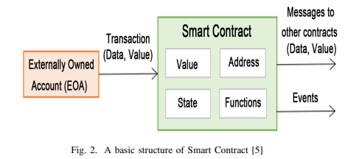
Cryptographic Primitives: Blockchain applies cryptography as a significant aspect in terms of security. The use of public-key cryptography enables users to sign their messages with their private keys and be authenticated and non-repudiated by the other users with the help of their public keys. Cryptographic hash functions produce deterministic-sized digests or hash values of information that are dependent upon any changes made to their input and that can be used to indicate that they have been altered. The merkle trees allow a request of the presence of a transaction in the block without downloading a complete block. Outside of primitives, like zero-knowledge proofs, it is possible to have systems like Zerocash (Ben-Sasson et al.) in which the user of an application can prove that they have enough money without revealing their balance.

B. Information Assurance Principles
Information assurance involves information systems and data protection strategies and practice. The field has five objectives which are typically considered:
Confidentiality: Only authorized persons should be allowed to access the information. Under traditional systems, it comprises access controls, encryption and secure channels. Confidentiality is compromised in blockchain environments since most blockchain architectures are based on transparency--the users are able to access all the transactions. Balancing blockchain transparency and privacy needs requires unique algorithms such as encryption, off-chain storage, or zero-knowledge proofs.
Integrity: Ensuring that any information has not been manipulated or lost in unauthorized manners. Integrity also encompasses authentication, which could follow that the data is of the asserted sources. Blockchain is excellent in terms of integrity protection by its cryptographically connected chain structure and consensus mechanisms that avoid unauthorized modifications. The distributed validation and append only feature ensure that it is very tough to tamper with.
Availability: Ensure information and systems are accessible when needed. Blockchain’s distributed nature provides strong availability guarantees—the system continues working even if individual nodes fail. However, network-level attacks or consensus failures can still impact availability.
Authentication: Verifying the identity of users, devices, or systems. Blockchain systems use public-key cryptography for authentication, with each user having a private key that proves their identity without requiring central authentication authorities.
Non-Repudiation: Preventing parties from denying previous actions. Blockchain transactions include digital signatures that cryptographically prove who authorized each transaction, creating strong non-repudiation guarantees that exceed traditional systems where logs might be alterable by administrators.

III. Research Methodology
We have searched peer-reviewed publications (2016-2024) on blockchain in IA on IEEE Xplore, ACM, Springer, Elsevier, and arXiv. Inclusion: empirical assessments or analysis systems on security, privacy or trust. Omission: advertising. Out of 150+ papers, we narrowed on 24 high-quality papers on foundational works, security analyses, privacy innovations, performance analyses and domain applications (finance, healthcare, supply chain, identity).

IV. Blockchain Mechanisms and IA Objectives
It is important that practitioners in the process of determining the right technologies understand how certain aspects of blockchain can play a role in information assurance goals. This part gives our mapping of taxonomy of blockchain mechanisms to IA objectives.

A. Integrity and Non-Repudiation
The blockchain technology is excellent at offering integrity and non-repudiation assurances, which are the basis of information assurance.
Immutable Ledger Structure: Blockchain is fundamentally designed to enforce a tamper-evident record through cryptographically binding one block to the previous one, with hash functions. Any alterations to any historical transaction would alter the hash of that block, disconnecting it with the following block and necessitating the re-computation of all the following blocks. In a proof-of-work system such as Bitcoin, this recalculation must be performed by using colossal computational resources which increase exponentially with the block depth. Gervais et al. examined the evidence of the security of a proof-of-work blockchain, and they have proved that it is exponentially harder to rewrite several blockchain blocks as time passes, which means that it is nearly impossible to tamper with history with established blockchains.
To quantify this property, immutability can be expressed as the complement of the probability that an attacker can successfully rewrite blockchain history. Let P(z,q) denote the attacker’s success probability derived from Nakamoto’s probabilistic security model. We define a Blockchain Immutability Score (BIS) as:
BIS(z,q)=1−P(z,q)
Where z is the block depth (number of confirmations),q is the fraction of total hash power controlled by the attacker,p=1−q is the fraction controlled by honest miners.This formulation captures key intuitions of blockchain security;increasing block depth (z) increases the amount of computational work required to rewrite history, greater honest hash power (p) strengthens resistance against attacks, greater attacker hash power (q) weakens immutability guarantees.
A BIS value approaching 1 indicates that the ledger is practically immutable, while a value approaching 0 indicates that the ledger can be easily rewritten.From an information assurance perspective, BIS provides a quantitative integrity metric, demonstrating how blockchain immutability emerges from cryptographic chaining, economic cost, and decentralized consensus rather than reliance on trusted authorities.
Probabilistic Integrity and Double-Spending Resistance:
The integrity guarantees of PoW blockchains are probabilistic rather than absolute. Nakamoto formalized this property by modeling the competition between honest miners and an adversary attempting a double-spending attack as a stochastic process. Let q denote the fraction of total mining power controlled by an attacker and p=1−q the fraction controlled by honest miners. If a transaction is buried under z confirmations, the probability that an attacker can eventually catch up and reverse the transaction is given by:
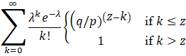
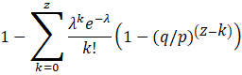
Where:
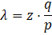
This formulation shows that the probability of a successful double-spending attack decreases exponentially as the number of confirmations z increases, provided the attacker controls less than half of the total hash power. This quantitative relationship underpins the widely adopted practice of waiting for multiple confirmations before considering transactions final. From an information assurance perspective, this model provides a measurable and analyzable integrity guarantee rooted in economic and computational assumptions, rather than reliance on trusted intermediaries.
Digital Signatures:. Authorization is done cryptographically by signing every blockchain transaction using the private key of the sender. The signatures are highly non-repudiable - participants cannot deny signing transactions. In contrast to the old systems when the administrator with higher privileges may corrupt the audit logs, the blockchain signatures are checked by all the nodes and become members of permanent and distributed record that cannot be changed by any other party.
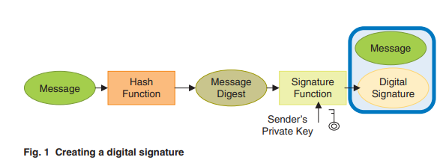
Merkle Trees and Proofs: Blockchain systems operate based on Merkle trees that are used to structure transactions in blocks so that it is possible to efficiently prove that a particular transaction is present in a particular block without knowing all the transactions or downloading the full block information.This allowing lightweight clients (devices without full blockchain copies) to verify transaction and support applications requiring proof of existence or temporal ordering without maintaining complete blockchain state. This efficiency is important for mobile wallets and IoT applications.
This structure enables Merkle inclusion proofs, which allow a verifier to confirm that a specific transaction is included in a given block without downloading or storing the entire set of transactions. Let bi​ be a transaction and hi = H(bi) its corresponding leaf hash. A Merkle proof for bi consists of the set of sibling hashes along the path from hi​ to the Merkle root. The verifier reconstructs the root hash by iteratively computing:
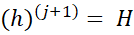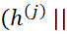
where h(0)=hi & sj​ denotes the sibling hash at level j of the tree. If the final computed value equals the Merkle root stored in the block header, the transaction is proven to be included in the block.
The size of a Merkle proof grows logarithmically with the number of transactions, requiring only O(logn) hashes for a block containing nnn transactions. This efficiency makes Merkle proofs particularly well-suited for lightweight clients, such as mobile wallets and Internet of Things (IoT) devices, which do not maintain a full copy of the blockchain. By verifying only block headers and Merkle proofs, these clients can independently validate transaction inclusion, supporting applications that require proof of existence, temporal ordering, and auditability without maintaining the complete blockchain state.

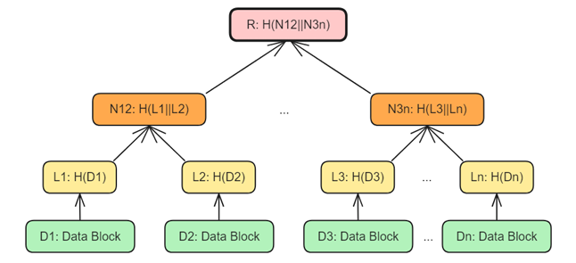
Timestamping: The blocks have time stamps on them and are sequentially arranged to provide a record of events that can be audited. This time ordering may be useful in establishing precedence (which transaction occurred first) and detecting backdating (manipulation of timestamps by unscrupulous parties), as well as in time-sensitive compliance requirements other than with regulatory reporting time limits or contract execution time limits.
Blockchain timestamping is achieved by embedding temporal information into a cryptographically linked sequence of blocks. Each block Bi can be modeled as Bi = <Ti,Di,H(Bi-1)> where Ti denotes the block timestamp, Di represents the block data, and H(Bi-1) is the hash of the preceding block. The cryptographic dependency between blocks enforces a strict temporal ordering such that Ti > Ti-1, meaning that blocks, and the transactions they contain, are probably ordered in time. Any transaction included in block Bi is therefore guaranteed to have existed no later than Ti. Attempting to modify or backdate a timestamp would change the block hash H(Bi) = H(Ti || Di || H(Bi-1)), thereby invalidating all subsequent blocks and requiring infeasible recomputation of proof-of-work or re-execution of consensus. This mechanism provides tamper-evident, auditable time ordering of events, supporting information assurance objectives such as integrity, non-repudiation, proof of existence, and compliance with time-sensitive regulatory and contractual requirements.
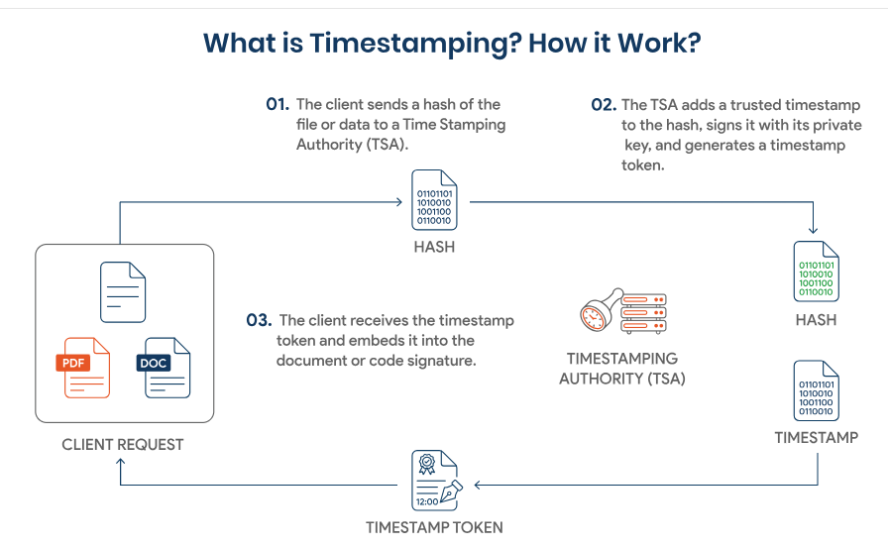

B. Availability and Resilience
The decentralized nature of blockchain has inherent advantages of availability over centralized systems at a certain cost.
Decentralized Replication: Compared to the traditional databases where the primary servers and backup systems are the main causes of potential single point of failure, blockchain data has been replicated so that there are hundreds or thousands of nodes of the data distributed across the globe.. The system does not have single points of failure, as it is also available and operational as long as there is a decent amount of honest nodes that will keep running. Such duplication offers resilience in the event of failure in hardware, natural disasters on certain geographical areas and even attacks on individual infrastructure.
Fault Tolerance Through Consensus: Byzantine Fault Tolerant (BFT) consensus protocols provide strong fault tolerance guarantees by allowing the system to continue operating correctly in the presence of arbitrary or malicious node behavior. Formally, a BFT system consisting of nnn participating validators can tolerate up to f Byzantine nodes while preserving both safety (no two honest nodes commit conflicting states) and liveness (the system continues to make progress), provided that the following condition holds:
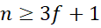
Equivalently, the maximum number of faulty nodes that can be tolerated is:
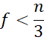
Under this threshold, protocols such as PBFT, Tendermint, and the ordering service in Hyperledger Fabric guarantee deterministic finality, meaning that once a block is committed, it cannot be reverted without violating protocol assumptions. This property offers strong information assurance guarantees for integrity and availability, particularly in permissioned blockchain environments where validator identities are known and governed. However, exceeding this Byzantine threshold compromises either safety or liveness, underscoring the importance of careful participant selection and governance in BFT-based blockchain systems.
Limitations and Challenges: Although blockchain is theoretically very available, there are practical issues. Network partitions may briefly divide the blockchain into incommunicado segments, which cannot interact, but in a system with network connectivity, the system heals when all is reconnected. Although failing to agree is rarer with well-designed systems, such failures can bring the whole transaction processing to a standstill. Proof-of-work systems have the theoretical possibility of using concentrated mining power to censor particular transactions. The performance bottlenecks may leave transaction backlogs when there is high demand, and this has the effect of reducing the availability of transactions. Such restrictions imply that blockchain availability guarantees, but strong, do not hold and that they need to be designed carefully.

C. Confidentiality and Privacy
The most difficult information assurance goal of blockchain is confidentiality, as transparency (to validate distributed) and privacy (to comply with regulations and user requirements) are in conflict with each other.
Encryption:By encrypting data, one can achieve confidentiality against unauthorized observers in case of storing it on blockchain. There are however some serious limitations to this approach. Smart contracts can never process encrypted data without special methods such as homomorphic encryption or secure multi-party computation, which are both highly complex and very expensive in performance. Data loss (loss of encryption keys) is irreversible and management must be critical about this issue. On-chain data which is encrypted cannot also be modified, which is problematic in cases when a quantum computer of the future cracks the existing encryption systems, revealing all of the past encrypted information.
Off-Chain Storage with On-Chain Commitments: It is common in many practical systems to store sensitive data off-chain (in private databases, encrypted file systems, and even distributed storage such as IPFS) and record cryptographic commitments (hashes or Merkle roots) on-chain. The architecture preserves integrity checks using the tamper-evident characteristics of the blockchain and keeps real information confidential and permits conventional access control measures. This pattern is widely implemented by healthcare applications, as thoroughly surveyed by Conti et al., as it is required to meet privacy laws such as HIPAA, but takes advantage of blockchain audit and tamper detection.
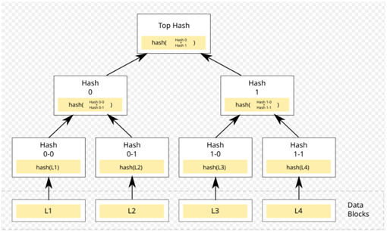

Zero-Knowledge Proofs:
Zero-knowledge proof (ZKP) systems are cryptographic protocols that allow a prover to convince a verifier of the validity of a statement without revealing any additional information beyond the truth of that statement. Formally, a ZKP enables a prover to demonstrate knowledge of a secret witness w such that a publicly known relation R(x,w)=1 holds, without disclosing w itself. A ZKP system satisfies three fundamental properties: completeness, meaning that an honest verifier will accept a valid proof with overwhelming probability; soundness, meaning that no dishonest prover can convince the verifier of a false statement except with negligible probability; and zero-knowledge, meaning that the verifier’s view of the protocol is computationally indistinguishable from a simulated transcript, i.e., Viewv(x) ≈ S(x), ensuring no information leakage. In blockchain systems such as Zerocash and Zcash, zk-SNARKs are employed to prove that transactions are valid (e.g., the sender owns sufficient funds and no double-spending occurs) while keeping transaction amounts, sender identities, and receiver identities hidden from all observers. Although these techniques provide very strong confidentiality guarantees even against global adversaries, they incur high computational overhead during proof generation, require complex cryptographic setups, and introduce implementation risks due to their sophistication, making them significantly more expensive than traditional digital signature-based verification mechanisms.
Mixing and Anonymization: Service providers that mix or tumble transactions of many users obscure the connections between the senders and the receivers by pooling money and re-distribing it with delays. Zhang et al. examined incentive-compatible mixing schemes that guarantee honest behavior by the participants. Nevertheless, there are inherent technical analysis (virtuous scholars such as Meiklejohn et al. have devised the complex de-anonymization heuristics that, although mixing, can be probabilistically linked), as well as regulating (mixing can facilitate money laundering and other crimes) problems with mixing.
Secure Multi-Party Computation: MPC protocols enable many parties to jointly arrive at computations on their own data without exposing that data to other parties or using trusted third parties. Almeida et al. investigated the idea of using MPC together with blockchain to have privacy preserving smart contracts where contract logic is executed using encrypted or secret shared data. Practical implementation is however not feasible because it has high performance costs (orders of magnitude slower than plaintext calculation) and high communication complexity (many message rounds) and coordination problems (when the parties are unreliable or malicious).
Trusted Execution Environments:MPC protocols enable many parties to jointly arrive at computations on their own data without exposing that data to other parties or using trusted third parties. Almeida et al. investigated the idea of using MPC together with blockchain to have privacy preserving smart contracts where contract logic is executed using encrypted or secret shared data. Practical implementation is however not feasible because it has high performance costs (orders of magnitude slower than plaintext calculation) and high communication complexity (many message rounds) and coordination problems (when the parties are unreliable or malicious).

D. Authentication and Access Control
Blockchain systems are cryptographically strongly authenticated and may be used to provide advanced access control in permissioned environments.
Public Key Infrastructure: Blockchain participants are authenticated using public-key cryptography without reliance on centralized certificate authorities. Each participant locally generates a cryptographic key pair (sk,pk) $←$ KeyGen($1^{λ}$), where the private key sk is kept secret and the corresponding public key pk is shared publicly or derived as a blockchain address. Transactions are authorized by digitally signing the transaction data m using the sender’s private key, producing a signature σ= Sign(sk,m). Any network participant can verify the authenticity and authorization of the transaction by checking Verify(pk,m,σ)=1, which proves that the transaction was created by the legitimate holder of the private key without revealing the key itself. Because public keys and signatures are validated collectively by the network through consensus, blockchain systems eliminate the need for centralized authentication authorities and avoid their associated single points of failure and trust assumptions. This decentralized PKI model provides strong guarantees of authentication, integrity, and non-repudiation, which are foundational to information assurance in distributed ledger systems.
Decentralized Identity: Ali et al. have researched decentralized identities (DID) using Blockstack, and Hardjono and Smith on decentralized public key infrastructure (DPKI) based on blockchains. These systems allow the user to manage their identity credentials, without having to use centralized identity providers such as governments or corporations. The models of self-sovereign identity enable users to administer their own credentials, share particular aspects of them selectively (such as demonstrating age without revealing date of birth), and recall credentials in case of an intrusion.
Role-Based Access Control in Permissioned Chains:There are fine-grained access controls in Permissioned block chains such as Hyperledger Fabric. With special privileges, administrators have the ability to create roles (e.g. auditor with read-only access, validator who certifies transactions, transaction submitter who creates new records). Smart contracts are capable of applying access policies in a programmable way, such as ensuring that the submitter of a transaction has relevant credentials before performing sensitive operations, such as transfer of funds may be executed, or data must be altered.
Verifiable Credentials: This allows verifiable credentials systems, where the issuers (governments, universities, employers) testify to the attributes of the users (citizenship, degrees, employment status), users store these credentials in digital wallets, and the verifiers ensure their correctness by cryptographic verification, without any contact to the original issuer (privacy leakage reduction), or without depending on the availability of the issuers (removal of dependency on availability).

E. Auditability and Governance
The transparent registry of blockchain offers unprecedented auditability features, although it needs to be designed with choices in transparency versus privacy.
Transparent Transaction History: In permissionless blockchains such as Bitcoin and Ethereum, all the transactions are publicly available and recorded permanently, and anybody can perform an extensive audit. Any individual can check the whole history of the transaction since the genesis block to the current time, and verify on their own that every transaction is in line with the protocols. This disclosure helps in fraud detection, monitoring flow of money within the system to enable regulatory inquiries and compliance to system rules without the report of any authority.
Time-Stamped Events: Blockchain possesses a chronological and chronological nature that creates an audit trail that is impossible to erase and may be utilized during compliance and forensic investigation. The chain of events will be able to be structured by investigators as a whole, determine the time of performing some actions, and verify whether the actions were performed according to the procedures and authorization. It would come in very handy in regulatory compliance in financial services and healthcare.
Smart Contract Enforcement:Smart contracts are business rules and policies that are written in verifiable and executable code. Every smart contract execution is in-chain, and this accumulates a comprehensive audit trail of automated decisions. That allows holding algorithmic governance to account and assists in making sure that automated systems act in line with the defined rules and not an obscure logic.
Challenges in Privacy-Preserving Auditability: It is difficult to have the privacy and auditability goals at the same time because they are incompatible. Decentralized blockchains are maximally transparent to audit and invasion of privacy. Fully privatized blockchains ensure confidentiality and, at the same time, prohibit audit. Practical solutions usually consist of selective disclosure (authenticated auditors have access to transaction information that unauthorized parties cannot access) or zero-knowledge proofs of compliance (systems can demonstrate to regulators that transactions meet regulations without making available transaction information).
Governance Structures: Governance defines the ways in which decisions are reached in regards to protocol upgrades, parameter adjustments and dispute resolution. On-chain governance is transparency-enhancing and based on smart contracts and token-voting, which is vulnerable to voter apathy and concentration of wealth. Off-chain governance is based on community discussion and rough consensus and is flexible, but is not always held transparently. Permissioned consortiums follow structures of corporate governance that entail legal agreements. Good governance is fundamental in the viability of the system in the long run and stakeholder confidence.
Regulatory Compliance: Blockchain systems have to operate in complicated regulatory environments. Permission-less systems where the participants take on a pseudonymous identity have a challenge in implementing financial regulations (AML/KYC), whereas permissioned systems where members are identified have an easier time with such regulations. The regulations on data protection (GDPR, CCPA) generate tensions with immutability by providing the right to be forgotten. The medical laws (HIPAA) demand the confidentiality of patient information. There are industry-specific standards (ISO 27001, PCI-DSS) that are a basis of security. Approaches to compliance Compliance is typically achieved by means of controlled participation within permissioned systems, and creative approaches are needed in permissionless systems such as storing data off-chain or privacy-preserving methods.

V. Security Threats and Defenses
Blockchain has a high level of security attributes, but it is vulnerable to various threats. The threat environment is the key to creating secure IA systems..

A. Consensus-Level Attacks
Blockchain has its security basis on the consensus mechanism. Any consensus-related attacks may compromise the integrity of the whole system.
51% Attacks: In Proof of work systems, a network with greater than half the available hash power is vulnerable to attacks by the attacker because they can reject all other miners and use their coins to perform a double-spending attack (use the same coins twice). Where large public blockchains such as Bitcoin have huge hash rates where such attacks are costly economically (millions per hour attack cost), smaller cryptocurrencies have been compromised with 51% attacks costing millions of dollars. Gervais et al. give a thorough examination of situations where such attacks are made possible and the cost thereof, such as network latency, and block propagation times.
Selfish Mining: This is a more advanced form of the previous one, where attackers mine blocks but plan to withhold them strategically to release at the right time, and thus make honest miners waste resources on orphaned blocks. This further raises the relative rewards of the attacker in comparison to his proportional hash power. The attack can be done with less than 51 percent hash power, but it must be well timed and have good network conditions.

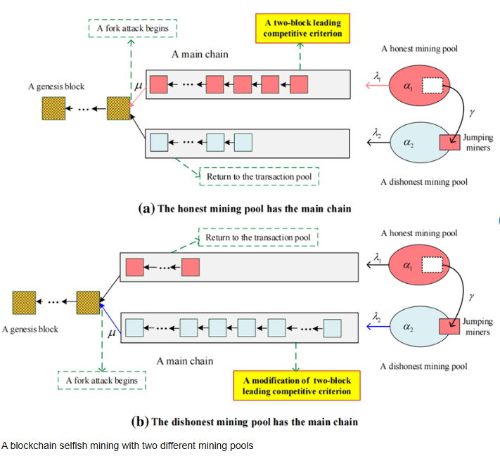
Long-Range Attacks: These are unique to proof-of-stake systems in that attackers obtain old private keys of accounts that have since sold their stake (keys are cheaply sourced because they no longer operate valuable assets) and reconstruct an alternate blockchain history dating a long time back. Countermeasures involve check pointing (periodically finalizing the blocks which cannot be undone), weak subjectivity (the new nodes need to acquire the recent blockchain state with trusted sources), and the mechanisms of key evolution that do not allow old keys to sign new blocks.
Eclipse and Partition Attacks: Network attacks that single out victims of the honest network. Attackers are in charge of all connections in the network of a victim and feed fake blockchain state as well as deny communication with honest nodes. This may be used to help attack the victim with the help of a double-spending attack or permit other consensus manipulations. Diversity in peer ties (linking to numerous independently-chosen peers), cryptographic authentication of nodes and anomaly reporting of suspicious network signatures are all requirements of defense.
Defenses: Consensus security is to be effectively multi-layered. The larger the number of miners/validators (high participation), the more expensive it is to attack as the amount of hashing power or stake is raised. Economic rewards such as slushing (destroying stake of those validators who are misbehaving in PoS systems) build a potent anti-deterrent. Formal security demonstrations offer assurance of consensus protocols on certain adversarial assumptions and models. Anomaly detection in monitoring systems is used to identify abnormal behavior such as an abnormal fork rate, or network partition. In important applications, the defence in depth of using multiple consensus mechanisms or anchoring to multiple blockchains is important.
B. Smart Contract Vulnerabilities
Although smart contracts may provide a high degree of functionality, they also pose serious security issues that have cost companies and individuals huge sums of money.
Reentrancy Attacks: The notorious 2016 DAO attack was a reentrancy attack that used the reentrancy vulnerability in which a malicious contract can recursively call into the victim contract prior to the initial invocation making its state updates, effectively withdrawing funds on multiple occasions. The attack cost about 60 million and resulted in an Ethereum hard fork that was controversial. This weakness was caused by the fact that contracts updated their state after (not before) external calls (which is a violation of the checks-effects-interactions pattern). Atzei et al. give a more detailed taxonomy of Ethereum smart contract attacks including reentrancy variants.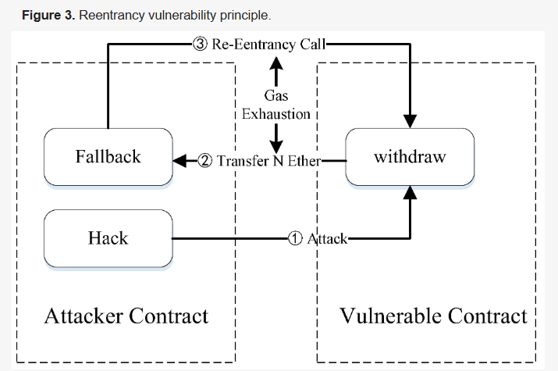
Arithmetic Errors: Integer overflow and underflow bugs arise when arithmetic operations are out of the range of the numeric type, which causes the operation to loop around to some unexpected value. An attacker may make a balance overflow (take a large positive value) to zero or a small value or underflow (take zero to a very large value) to make value. The current development patterns consist of SafeMath libraries, which verify arithmetic errors and rollback transactions in case of errors, although older contracts and contracts that do not use a SafeMath library are vulnerable.
Access Control Flaws: There are access control flaws that are implemented improperly allowing access to privileged functions that should be restricted to unauthorized users. Examples are the lack of missing function modifiers that restrict the callers to administrators, unsupported initialization functions, only called during deployment, or hairballs of dependency where a contract unwillingly provides service to attackers via the complex chain of calls..
Oracle Manipulation: Smart contracts frequently require external information sources (oracles) which supply real-world information, such as asset prices, weather, or sport scores. There are attackers who are capable of manipulation of the oracle data which may lead to wrong decisions made by contracts. Manipulation of price oracles Attacks on decentralized finance platforms that use flash loans have been used to exploit manipulation of market prices and oracle updates based on manipulated prices to make a profit on contracts at stale prices and repay the loan in a single atomic transaction. Daian et al. evaluated maximum extractable value (MEV) that indicates how validators can get profits by strategizing the order of transactions.
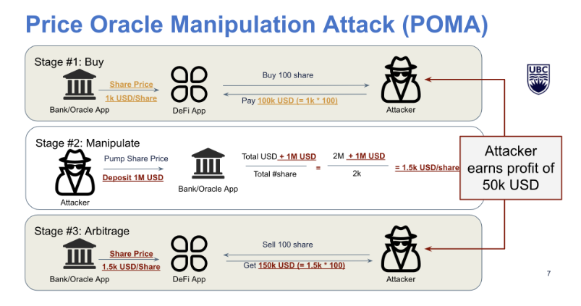
Defenses: To mitigate the vulnerability of smart contracts, there is a need to take multifaceted strategies. The secure development lifecycle practices are threat modelling in design, security oriented design patterns (checks-effects-interactions to prevent reentrancy, pull-over-push to distribute payments) and compliance with accepted standards and best practices. Such automatic analysis tools as Oyente (created by Luu et al.) find known vulnerabilities using symbolic execution and data flow analysis, but they are not able to identify every problem. Ad hoc professional security audits by expert auditors uncover latent weaknesses unnoticed by automated tools by conducting a manual review of source code and through trying to reason as an attacker. Formal verification Formal verification mathematically establishes that contracts meet security properties, which offers maximum confidence, but it is nevertheless costly and can only be accomplished by expert knowledge. Bug bounty programs encourage independent security researchers to discover and report vulnerabilities in a responsible manner before the vulnerabilities are exploited maliciously. With runtime monitoring and circuit breakers, the damage can be restricted in case the vulnerabilities are used in spite of the preventive measures employed by permitting the emergency suspension of the vulnerable contracts.

C. Key Management Risks
The blockchain systems are based on the cryptographic keys in terms of authentication and authorization. The loss or compromise that is key puts the assurance of information under a direct threat that in most cases cannot be reversed.
Private Key Theft: In case the attackers steal a user private key, via malware, phishing or by providing unsafe key storage or by compromising hardware, they can have full control of the user, they can impersonate him, authorize any transaction and access all the resources protected. In contrast to a conventional password system, where the breached accounts can be commonly restored by simply resetting the password or reclaiming the account, stolen blockchain keys almost always lead to the inability to recover any assets or access permanently.
Key Loss: When the user loses his or her own key (due to hardware failure, forgotten passwords to encrypted keys, physical loss of storage media, etc.), he or she will never be able to access the account or its assets again. There is no central entity to reset blockchain keys or restore lost accounts. This ruthless character renders key backup extremely vital and poses a strain with the security-backed up keys are other attack surfaces which need to be secured.
Defenses: The threats that are associated with the key-related need to be countered with multiple layers. The hardware wallets (specific devices that create and store keys in a secure part that is not touched by any general-purpose computers) are highly malware-resistant. Multi-signature schemes are based on multiple keys that are independent and are necessary to support transactions and spread trust in case of one key loss or compromise. The threshold signatures apply cryptographic secret-sharing mechanisms such that fewer shares of the key (e.g., 3 out of 5) are required to sign transactions, and even in cases where some shares are lost, key recovery is still possible without jeopardizing the security. Social recovery systems help users assign trusted people (friends, relatives, professional services) to get access to accounts via cryptographic. Hierarchical deterministic (HD) wallets derive many keys out of the same master seed, such that it is easy to backup one master seed value and retain key diversity in another purpose. In the case of enterprise applications, Hardware Security Modules (HSMs) offer tamper resistant storage of keys under strict access control, audit trails and certification to comply.
D. Network and Peer-to-Peer Threats
Blockchain systems operate over potentially hostile networks, facing threats common to distributed systems plus blockchain-specific attacks.
Sybil Attacks: Attackers create multiple fake identities to gain disproportionate influence in the system. In networking contexts, this might mean connecting to victims through many attacker-controlled nodes to facilitate eclipse attacks. In governance contexts, it could mean creating fake accounts to manipulate voting or decision-making processes. Proof-of-work and proof-of-stake mitigate Sybils for block creation by tying influence to costly resources (computation or financial stake), but application-level Sybil resistance remains challenging.
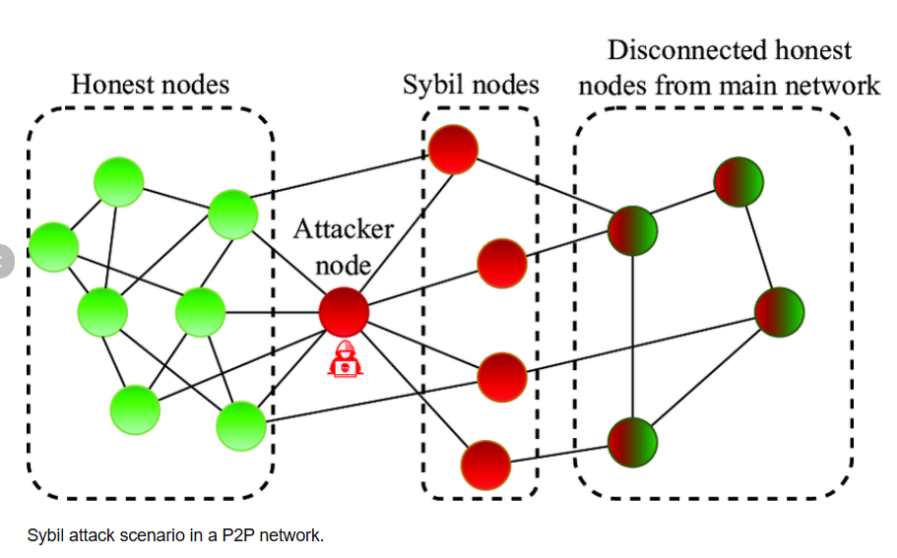
Maximal Extractable Value (MEV): Miners or validators can extract value by strategically ordering, including, or excluding transactions within blocks they produce. For example, they might front-run profitable trades on decentralized exchanges (observing pending transactions, inserting their own transactions to execute first, profiting from price movements their transactions cause). Daian et al. analyzed MEV in depth, demonstrating how it creates consensus instability (validators might reorganize recent blocks to capture MEV opportunities) and unfair transaction ordering that undermines application security.
Defenses: Robust P2P network design has a variety of peer connections to avoid the eclipse attacks (connecting to a large variety of nodes with diverse network locations and characteristics), node-to-node communication is encrypted and authenticated to avoid eavesdropping and tampering, and the protocol is carefully designed to limit the amount of resources that a single peer may consume avoiding the resource exhaustion attacks. Other systems do use gossip protocols with redundancy that each transaction is sent to the nodes via multiple independent paths and the effect of a single malicious node is minimized.

E. Privacy Leakage
Although blockchain systems do not demand the use of real names but instead pseudonyms, user privacy can still be breached by their determined opponents using different methods of analysis.
Transaction Graph Analysis: Meiklejohn et al. showed that comprehending the graph structure of Bitcoin transactions (who paid whom) enables grouping addresses that are probably those of the same user in common input ownership heuristics and other tendencies. These clusters can be then associated with real world identities through addresses familiar to them such as exchange withdrawal address, publicly posted address on donations or addresses that are disclosed during purchase transaction. This deanonymization is even in the presence of pseudonymity since patterns and relationships of transactions provide a lot of information about user identities and user behaviors.
Defenses: To protect privacy, it would be necessary to actively do more than simple pseudonymity. Transaction mixing services provide obscurity to the linkages but at the expense of regulatory issues and exposure to advanced analysis. Privacy-conscious cryptocurrencies such as Monero (with ring signatures and stealth addresses) and Zcash (with zero-knowledge proofs) do not reveal the information about transactions but default; that is, they do not work by users having to use the privacy features. Privacy of certain transactions can be ensured using layer-2 solutions and sidechains, which anchor with public chains to guarantee security. In the case of permissioned blockchains, there are access controls that govern the people who look at the transaction data. User education is required in every situation, even the advanced technical privacy protection cannot work in case of the user security errors such as using the same addresses in different contexts or associating blockchain identity with traditional ones.

VI. Privacy-Preserving Techniques
Privacy is one of blockchain’s most challenging aspects for information assurance. While transparency enables auditability, it goes against confidentiality requirements. This section examines techniques for attaining privacy in blockchain systems.

A. Mixing Services
Concept: Mixing services (also called tumblers) combine transactions of multiple users and randomly mix them up to make it difficult to know who is sending and who is receiving. The cryptocurrency is sent to the mixer by its users and mixed with the funds sent by other users, with the equivalent amounts of money delivered (after delays) to designated addresses. This breaks direct on-chain links between sources and destinations.
Analysis: Privacy against non castral observers The right mixing with sufficient numbers and time delays provides adequate privacy. Zhang et al. analyzed the incentives-compatible mixing protocols that guarantee honesty within the participants. Mixing, however, contains some basic restrictions. Advanced attackers can use timing correlation (when money gets deposited and picked out of mixers), amount fingerprinting (different amounts of transaction) and repeated measurement as the basis of their probabilistic deanonymization of a transaction. The money might be stolen away or the transaction mappings could be stolen in case the mixers concocted are malicious, or the mixers themselves are spoiled. Scrutiny by the regulators restricts the use of mixing--in certain jurisdictions, it would be considered an offense to operate the mixing services, and users might be subjected to greater scrutiny of exchanges.

B. Zero-Knowledge Proofs
Foundations: Zero-knowledge proofs (ZKPs) are cryptographic mechanisms where provers are allowed to prove the verifiers correct about statements and to not provide any information about anything other than the truth of the statements. This seemingly unimaginable quality allows strong privacy preserving applications.
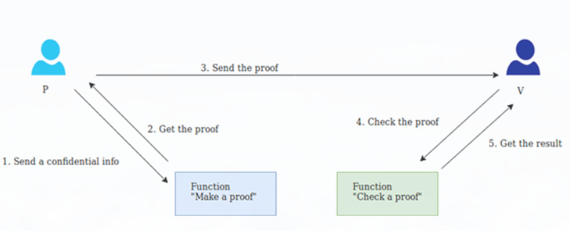
Zerocash: ZKPs have a transformative capacity, which is exhibited by the Zerocash protocol by Ben-Sasson et al. Zerocash is unaware of the senders, receivers or the transaction amounts using zk-SNARKs ( Zero-Knowledge Succinct Non-Interactive Arguments of Knowledge ) but it enables networks to confirm whether or not the transactions are valid ( senders possess enough funds, amounts balance correctly, there is no double-spending). This will create Zcash cryptocurrency that offers users a choice between transparent and shielded transactions in which shielded transactions offer near unmatched privacy, even to the opponents that track all the blockchain data.
Technical Challenges: Even though ZKPs are quite powerful, they experience serious challenges in practice. The equivalent computationally cost of producing zk-SNARK is prohibitively expensive (in terms of measuring time on consumer hardware), between seconds and minutes per transaction. Most zk-SNARK constructions have the first trusted configuration, which introduces possible vulnerabilities- attackers may structure fake proofs in case they succeed in compromising the setup parameters. Newer constructions like zk-STARKs eliminate trusted setup at the cost of larger proof sizes. The complexity of implementation makes them more exposed to the existence of subtle bugs that would entirely nullify privacy or correctness.
Applications: In addition to cryptocurrencies, ZKPs can be used to help in privacy-preserving smart contracts such as where inputs, outputs and intermediate states are hidden and yet, it is possible to verify that the smart contract was executed correctly. ZKPs can facilitate regulatory adherence to financial regulations in which depository institutions can prove that they are holding reserves at thresholds required without revealing actual asset ownership(as explored by Boneh et al.). Identity systems can use ZKPs for selective disclosure—proving age without revealing birthdates, proving credentials without revealing identities.

C. Confidential Transactions
Pedersen commitments are used in the confidential transaction schemes to obscure the amounts of the transactions. Commitments cryptographically bind to values without revealing them. Committed amounts can be verified to balance (inputs equal outputs) without knowing actual values. Range proofs (usually implemented using Bulletproofs) prevent attackers from creating negative amounts or exploiting commitment properties to inflate supply. Confidential transactions obscure amounts but not sender/receiver information or graph structure of transactions, providing a valuable middle ground—offering stronger privacy than fully transparent systems, & better performance than full ZKP systems like Zerocash.

D. Off-Chain Storage
Most real-world systems keep sensitive data (off-chain) in the form of private database or distributed file systems but store cryptographic hash (on-chain). This sustains the integrity checking using blockchain but actual data remains hidden. Healthcare applications normally adopt this pattern in order to meet privacy regulation goals by taking advantage of audit capabilities presented by blockchain (Conti et al.). Advantages are privacy, performance and utilization of existing infrastructure. Disagreements such as off-chain availability dependencies and split architecture are limitations.

VII. Permissionless vs. Permissioned Blockchains
Permissionless and permissioned blockchain architectures differ greatly on the property of information assurance.

A. Permissionless Blockchains
Characteristics: Systems such as Bitcoin and Ethereum are open to participation by anyone. Any person can operate nodes, submit transactions, and even be involved in consensus (mining in PoW, staking in PoS). The blockchain status is open - any individual can view every transaction and check its full context.
Security Advantages: The permissionless systems are characteristically very integrity insured with massive decentralization. Since the system has thousands of independent participants located around the globe, no single entity has control over it and is able to change history at its own unilateral will. This is because transactions cannot be easily blocked or reversed by any authority due to this opposition to censorship. It can be publicly verifiable, that is, any individual is permitted to audit the entire system without any privileges.
Privacy Challenges: Public visibility introduces significant privacy concerns, as all transaction data is permanently recorded and accessible to anyone. Users are identified by cryptographic addresses rather than real names; however, transaction graph analysis can reveal behavioral patterns and potentially link these addresses to real-world identities, as shown by Meiklejohn et al. To mitigate these risks, privacy must be achieved through additional mechanisms such as mixing services or zero-knowledge proofs, which increase system complexity and operational costs.
Performance Limitations: The process of reaching an agreement between thousands of mistrusted participants puts a constraint on throughput. Bitcoin can manage about 7 transactions per second; Ethereum (before sharding) is able to manage approximately 15-30 TPS. Such rates are much less as compared to conventional payment networks (Visa handles thousands of TPS) or databases. Rouhani and Deters compared the performance of Ethereum transactions processing and found that there are bottlenecks in validation, access to state, and the coordination of consensus.
Use Cases: Permissionless blockchains are better than environments where trust should be limited, where censorship resistance is critical and where the participants have an organizational spread with no collective control. Examples can be the public cryptocurrencies, applications in decentralized finance, and the systems that need maximum transparency and verifiability.
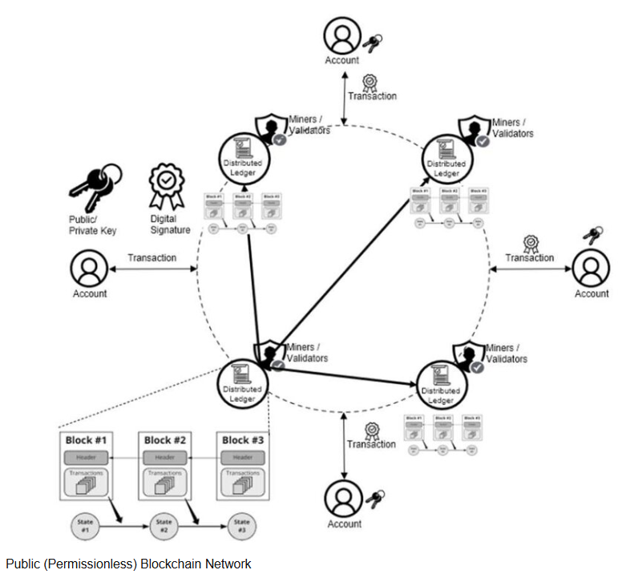

B. Permissioned Blockchains
Characteristics: Permissioned blockchains have the access restriction to identified, approved entities. The various organizations administer consortium blockchains; the individual blockchains are run by single organizations. These are Hyperledger Fabric (Androulaki et al.) and R3 Corda. Hashemi et al. compared several of the permissioned systems to be used in the enterprise.

Access Control and Privacy: Permissioned systems have fine-grained access controls. The permissions may be different to various participants, some may submit a transaction, others may verify blocks, another may simply read a specified channel of data. This enables enhanced privacy by separating data. Only authorized parties can view the transactions, facilitating compliance with confidentiality requirements while maintaining auditability for regulators.
Performance Benefits: Permissioned blockchains with known and trusted validators and with efficient consensus such as BFT have significantly greater throughput, with thousands of transactions per second being possible. Reduced latency and deterministic finality (understanding when the transactions have been finalized) would be appropriate to the enterprise-wide applications that need real-time processing.
Trust Model: Permissioned systems trade decentralization for efficiency. Users have to trust the consortium or organization controlling network access. Reduced decentralization increases risks of collusion, censorship, or unauthorized changes if governance is weak. Security is very essential in properly vetting participants and maintaining strong governance.
Regulatory Compliance: Permissioned architectures generally facilitate regulatory compliance. Know-your-customer and anti-money laundering requirements are straightforward when all participants are identified. Data protection regulations can be satisfied by controlling data visibility. Sector-specific compliance (HIPAA, SOX, PCI-DSS) is easier with controlled participation and configurable privacy.
Use Cases: Permissioned blockchains suit enterprise consortiums, supply chain networks, financial institutions, healthcare systems, and government applications where participants have existing relationships, regulatory compliance is mandatory, privacy is required, and high performance is necessary.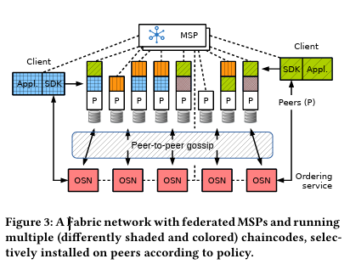
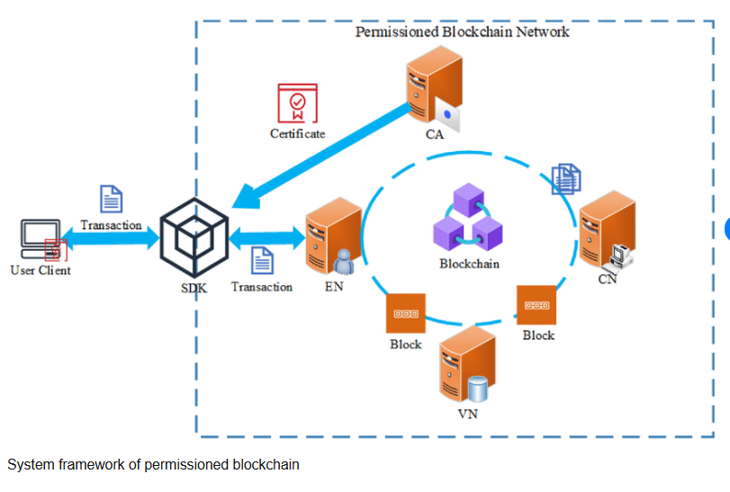

C. Hybrid Architectures
Recognizing that neither permissionless nor permissioned systems perfectly satisfy all requirements, hybrid approaches combine elements of both. A common pattern uses permissioned blockchains for private, high-performance transaction processing while periodically anchoring commitments (Merkle roots, state hashes) to public permissionless blockchains. This provides privacy and performance of permissioned systems with integrity assurance and public verifiability of permissionless systems. If the permissioned network is compromised, evidence remains on the public chain. Side chains and layer-2 solutions enable applications to choose appropriate security-performance-privacy trade-offs for different transaction types.

VIII. Smart Contracts and Oracles
Security Fundamentals: Immutability prevents both malicious changes and bug fixes. Public code visibility allows unlimited attack analysis. Financial nature makes contracts attractive targets.
Development Practices: Security-focused patterns (checks-effects-interactions, pull-over-push), automated analysis (Oyente), professional audits, formal verification for critical contracts, comprehensive testing, bug bounties.
Upgradeable Contracts: Proxy patterns enable logic updates. Risks: Unauthorized upgrades if access controls are weak. Solutions: Time-locked upgrades, governance-controlled changes, multisignature controls, circuit breakers.
Oracle Security: External data introduces trust points. Solutions: Decentralized oracle networks (Chainlink), cryptographic attestation via TEEs, manipulation-resistant designs (time-weighted averages), application-specific strategies.
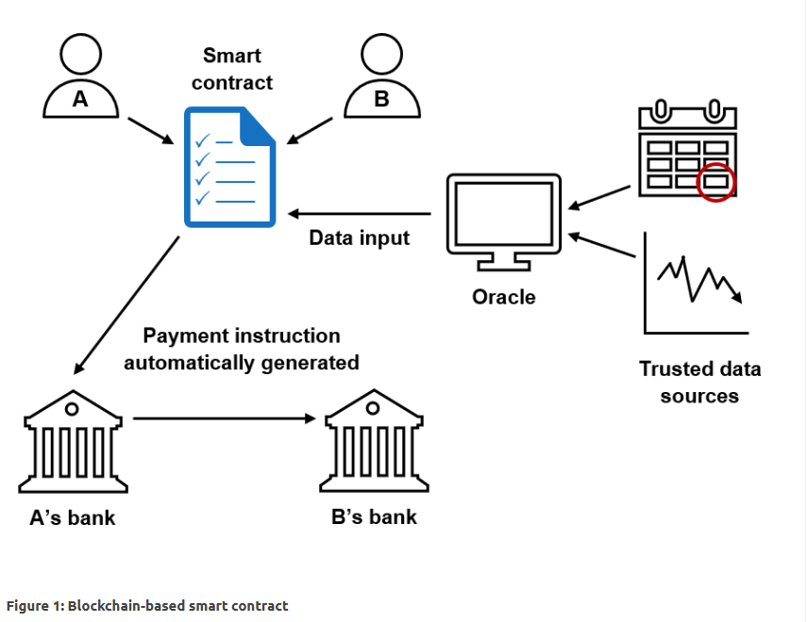

IX. Trust, Governance, and Compliance
Trust Dimensions: Technical: cryptographic soundness and consensus resilience; Economic: game-theoretic incentives; social; governance transparency; operational; reliability and support; legal; regulatory and compliance.
Governance Models: On-chain: transparent and vulnerable to voter apathy and wealth concentration; off-chain: flexible and opaque and sluggish but can be effective; permissioned: corporate governance supported by legal agreements; hybrid: can combine the merits of both models.
Regulatory Compliance:
- Financial: AML/KYC is ineffective in permissionless systems (Victor and Andelfinger made a lot of progress on detection) but much easier in permissioned systems.
- Data Protection: The right to be forgotten and blockchain immutability of GDPR is a massive collision. Common solutions include off-chain information, key-destroyed encryption, and privacy-by-design.
- Healthcare: There is a strong tendency to employ strict access control, audit log, and encryption to HIPAA compliance (Conti et al. put that in there) (Conti et al.)
- Standards: Standards to be used are NIST, ISO, IEEE.
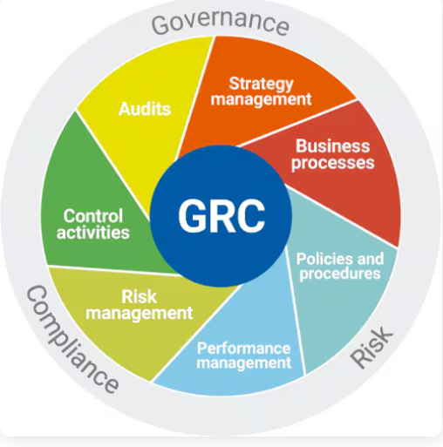
Compliance-by-Design: Considerable identity (DIDs, verifiable creds), automated monitoring, privacy-preserving compliance (such as ZK proofs to regulators), flexible architecture and active regulation participation.

X. Performance Considerations
Metrics: Throughput (Bitcoin can handle around 7 TPS, Ethereum around 15-30 TPS, permissioned example thousands TPS as compared to Visa record peak), latency and finality (Bitcoin can handle around 1 hour, BFT can be instant), scalability, resource usage (PoW needs energy usage), cost (variable gas fees).
Bottlenecks: Consensus overhead, state growth, network propagation, smart contract execution limits, verification costs.
Scaling Solutions: Sharding (parallel chains, Ethereum 2.0), layer-2 (state channels, rollups with ZK proofs), optimized consensus (PoS, delegated PoS), state management (rent, expiry), hardware acceleration.
Trade-offs: Block size vs. decentralization, finality vs. throughput, performance vs. security.Requirements right-size architecture, optimize application design, growth planning.

XI. Practical Design Patterns
Data Anchoring: Fundamentally it anchors your data to the blockchain through the dropping of a hash onto-chain. It also allows you to demonstrate integrity and keep your things private (keeps the book of record clean and your data a secret).
Tokenized Access Control: Consider tokens permission as badges that allow sharing access across teams without a single administrator in the middle, which means that it is audit-friendly and completely decentralized.
Event-Driven Auditing: In this, we publish event-driven information on each significant action, producing tamper-evident logs that can be inspected by anyone, and which are ideally useful in tracing suspicious actions with no additional work.
Layered Privacy: Configure multiple layers of privacy, public transparency, private business data, regulatory visibility and add encryption, ZKPs, and selective disclosure controls such that you only share the right information with the right individuals.
Key Recovery: integrate hardware wallets, multisig, social recovery, and HD wallets such that you enjoy high security and still have an ability to recover your keys without experiencing the nightmare of a do-it-yourself experience.
Defense-in-Depth: It provides defense-in-depth protection to all your layers network, platform, application, cryptographic protocols, operational procedures, and governance rules.

XII. Open Challenges and Future Directions
Scalable Privacy: I would love ZKPs to be faster like recursive composition and hardware acceleration, and practical MPC and smart contracts which ensure privacy.
Secure Interoperability: The interoperability of the unverified cross-chain bridges is costing people their money in the hundreds of millions, which is why we need formally verified cross-chain bridges.
Formal Verification at Scale: It must be practical using automated tools, friendly to verification languages, clear specification languages and real developer workflows.
Usable Key Management: Social recovery must be easy, threshold signatures are cool and we should not forget easy to use hardware to allow everyday users to use and biometric to offer options but institutional custody remains in the hands of the enterprise.
Adaptive Governance: It basically changes gears based on the circumstances using ordinary democracy for routine matters, emergency procedures when required, and expert technical judgments for complex issues. It relies on design mechanisms resistant to attacks and uses empirical metrics to assess real effectiveness.
Compliance-by-Design: It integrates traditional regulatory templates with automatic compliance audits so it can monitor everything in real-time. It uses cryptographic aids that assist in complying with the law right at the start.
MEV and Fairness: It ensures encrypted mempools and fair ordering everywhere to distribute MEV evenly, and have application-level defenses as suggested by Daian and co.
Environmental Sustainability: It goes beyond standard PoS to implement efficient consensus and smarter proof-of-work. It requires a full Life Cycle Assessment (LCA) to track environmental impact and adopts Post-Quantum Cryptography to guarantee proof-of-consistency against future threats.
Emerging Technologies: AI-blockchain hybrids will be used for fraud prevention. It further integrates IoT ecosystems through lightweight clients optimized for resource-constrained devices, while ensuring the entire infrastructure remains quantum-ready to withstand future computing threats.

XIII. Conclusion

A. Key Findings
Blockchain is just a best fit with integrity and non-repudiation of those immutable and cryptographically-signed ledgers. The distributed configuration provides it with super strength of availability. However, in case of confidentiality, you need to include additional technology ZKPs, off-chain storage, encryption. The actual suffering is performance: most applications are capped by throughput and latency. Smart contract security remains a sham; bugs continue to be high profile. Key management is one of the key adoption barriers.
The architecture is important: permissionless is ideal in terms of censorship resistance and public verifiability, but it has low throughput and privacy is a nightmare. Permissioned allows you to customize permissions, achieve superior performance and simpler compliance, but you are entrusting yourself to the supervisory authority. Hybrid models attempt to make compromises.
Privacy, security and performance are in a constant tug-of-war. ZKPs provide you with good privacy, but with compute pollution. A weaker privacy option although the one that runs faster is mixing. Off-chain sacrifices a certain degree of decentralization to the advantage of a more suitable combination of privacy and speed.
Security is not a sufficient condition and there must be good governance, compliance and response to incidents and management of stakeholders. Such points are equally crucial.

B. Recommendations for Practitioners
Adoption Decisions: To begin with, we need to stick the IA requirements. Determine whether or not blockchain vibe, which is decentralized, immutable, and transparent, can be the solution to what we are seeking. Otherwise, it can be performed by the traditional databases with good access controls.
Architecture Selection: Select permissionless, when we require censorship resistance against all kinds of untrusted players, but are able to tolerate management by some degree of slow throughput. Go permissioned to comply, privacy and speed, should you know what should be seen. A blend mix is functional when there are diverse needs of everyone.
Security: Take time to audit your smart-contracts, formally appreciate the decisive stuff, auto-tests, comprehensive testing, and even bug bounties. Good dev patterns, hardware wallets, multi-sig, and perhaps social recovery. Monitor incidences and maintain a plan of action.
Privacy: Headstart privacy. Apply the ZKPs when the difficulty to trace secrecy is required, store some information out of chain to make it more convenient, and implement permissions in permissioned environments. Board early Get GDPR, AML/KYC and sector rules.
Performance: Stress testing. Grow the architecture up to where it is. streamline the app - batch operations, off chain heavy lift, contracts simple. Prepare to expand and transition to more scalable technology.

C. Research Agenda
Near-Term (1-3 years): Better performance of ZKP, standardized interoperability protocols, usable key management, better tools of verification.
Medium-Term (3-7 years): Scale-privacy, Scale-effective level-2, Scale-effective governance, Regulatory being made clear.
Long-Term (7+ years): Cryptography that is quantum-resistant, AI-driven-blockchain synergies, sustainable consensus, multi-chain ecosystems without links

D. Final Remarks
Blockchain has received significant potential to improve information assurance in many settings, but it is not a panacea. To implement blockchain technologies effectively, careful needs analysis, prudent choice of architecture, integration of additional controls to reduce the intrinsic constraints, continuity security, sound governance, compliance with regulatory requirements and practical expectations of functionality and related trade-offs are essential.With the maturity of blockchain, in the form of privacy mechanism solutions, scalability solutions, development toolchain solutions, and governance model solutions, the scope of applicability increases dramatically. Organizations that undertake proper fit studies, use best-practice guidelines, and maintain adaptive flexibility will be in place to accrue significant advantages to information assurance.

Acknowledgments
We have our heartiest thanks to the blockchain research community who have been at the forefront in introducing distributed ledger technology in the sphere of information assurance.We also recognize the authors of reviewed literature whose strict methodological strategies form the basis of our synthesis.We also recognise practitioners who were involved in the creation of real-world systems, and whose experience provides a refined perspective of practical issues and solutions that are both possible.

References
[1] S. Nakamoto, "Bitcoin: A Peer-to-Peer Electronic Cash System," 2008.
[2] V. Buterin, "A Next-Generation Smart Contract and Decentralized Application Platform," 2014.
[3] G. Wood, "Ethereum: A Secure Decentralised Generalised Transaction Ledger," 2014.
[4] M. Swan, Blockchain: Blueprint for a New Economy. O’Reilly Media, 2015.
[5] E. Androulaki et al., "Hyperledger Fabric: A Distributed Operating System for Permissioned Blockchains," in Proceedings of the Thirteenth EuroSys Conference, 2018.
[6] J. Bonneau et al., "SoK: Research Perspectives and Challenges for Bitcoin and Cryptocurrencies," in IEEE Symposium on Security and Privacy, 2015.
[7] S. Meiklejohn et al., "A Fistful of Bitcoins: Characterizing Payments Among Men with No Names," in Proceedings of the 2013 Conference on Internet Measurement Conference, 2013.
[8] E. Ben-Sasson et al., "Zerocash: Decentralized Anonymous Payments from Bitcoin," in IEEE Symposium on Security and Privacy, 2014.
[9] B. Zhang and H.-A. Jacobsen, "Towards Dependable, Scalable, and Pervasive Distributed Ledgers," Proceedings of the VLDB Endowment, vol. 11, no. 12, 2018.
[10] J. Kwon and E. Buchman, "Tendermint: Consensus without Mining," 2014.
[11] P. Gaži, A. Kiayias, and A. Russell, "Proof-of-Stake Sidechains," in Financial Cryptography and Data Security, 2018.
[12] N. Atzei, M. Bartoletti, and T. Cimoli, "A Survey of Attacks on Ethereum Smart Contracts (SoK)," in Principles of Security and Trust, 2017.
[13] L. Luu et al., "Making Smart Contracts Smarter," in Proceedings of the 2016 ACM SIGSAC Conference on Computer and Communications Security, 2016.
[14] P. Daian et al., "Flash Boys 2.0: Frontrunning, Transaction Reordering, and Consensus Instability in Decentralized Exchanges," in IEEE Symposium on Security and Privacy (SP), 2020.
[15] S. M. Hashemi et al., "Evaluation of Permissioned Blockchain Systems for Enterprise Use," IEEE Access, vol. 8, 2020.
[16] M. Conti, A. Dehghantanha, K. Franke, and S. Watson, "Blockchain for Healthcare: A Survey," IEEE Access, vol. 6, 2018.
[17] O. Rouhani and R. Deters, "Performance Analysis of Ethereum Transaction Processing," in Proceedings of the 6th International Conference on Cloud Computing and Services Science, 2017.
[18] D. Boneh, B. Fisch, and A. Grewal, "Proofs of Solvency for Cryptocurrencies," IACR Cryptology ePrint Archive, Report 2019/46, 2019.
[19] M. Almeida et al., "Scalable Privacy-Preserving Smart Contracts with zkSNARKs and MPC," arXiv preprint arXiv:2107.12345, 2021.
[20] D. Hardjono and N. Smith, "Decentralized Identifiers and Verifiable Credentials for Identity Assurance," IEEE Communications Standards Magazine, vol. 5, no. 1, 2021.
[21] Y. Zhang, J. Katz, and C. Papamanthou, "Anonymity and Incentives in Blockchain Using Mixnets," arXiv preprint arXiv:1703.01769, 2017.
[22] A. Gervais et al., "Security and Performance Analysis of Proof-of-Work Blockchains," in Proceedings of the 2016 ACM SIGSAC Conference on Computer and Communications Security, 2016.
[23] F. Victor and V. Andelfinger, "Detecting Money Laundering in the Bitcoin Network," arXiv preprint arXiv:1907.05526, 2019.
[24] M. M. Ali et al., "Decentralized Public Key Infrastructure," in Financial Cryptography and Data Security, 2016.
[25] S. Eskandarian et al., "SoK: Transparent and Accountable Behavioral Rules with Smart Contracts," arXiv preprint arXiv:2005.08386, 2020.
[26] R. C. Merkle, “A Digital Signature Based on a Conventional Encryption Function,” in Advances in Cryptology—CRYPTO ’87, Berlin, Germany: Springer, 1988, pp. 369–378.
[27] R. C. Merkle, “Method of Providing Digital Signatures,” U.S. Patent 4 309 569, Jan. 5, 1982.
[28] D. Johnson, A. Menezes, and S. Vanstone, “The Elliptic Curve Digital Signature Algorithm (ECDSA),” Int. J. Inf. Secur., vol. 1, no. 1, pp. 36–63, 2001.
[29] M. Castro and B. Liskov, “Practical Byzantine Fault Tolerance,” in Proc. 3rd Symp. Operating Systems Design and Implementation (OSDI), New Orleans, LA, USA, 1999, pp. 173–186.
[30] S. Goldwasser, S. Micali, and C. Rackoff, “The Knowledge Complexity of Interactive Proof Systems,” in Proc. 17th ACM Symp. Theory of Computing (STOC), Providence, RI, USA, 1985, pp. 291–304.
[31] O. Kuznetsov et al., “Efficient and Universal Merkle Tree Inclusion Proofs via OR Aggregation,” Cryptography, vol. 8, no. 3, p. 28, 2024.
[32] R. Cramer, I. Damgård, and B. Schoenmakers, “Proofs of Partial Knowledge and Simplified Design of Witness Hiding Protocols,” in Advances in Cryptology—CRYPTO ’94, Berlin, Germany: Springer, 1994, pp. 174–187.
[33] D. Boneh and M. Franklin, “Identity-Based Encryption from the Weil Pairing,” in Advances in Cryptology—CRYPTO 2001, Berlin, Germany: Springer, 2001, pp. 213–229.

